

MindWorks Project

File Documentation



Darren Lee Wei Sheng

Tan Jiaqing

Neo Xue Qing Eden

Tan Mei Fang

Samuel Lau Kee Chia

Jacky Tan Jie Wei

Table of Contents

2 Main Folder 2

3 APK File 2

4 Archived Files 3

5 Art Assets 4

6 Documents 4

7 Final Working File 5

8 ITPS 2015 Materials 5

9 Videos 6

# Main Folder

Upon entering the main folder, there will be eight items visible. Six of the eight items are folders containing various elements of the project named, in alphabetical order, “Archived Files”, “Art Assets”, “Documents”, “Final Working File”, “ITPS 2015 Materials” and “Videos”. The remaining two files are an APK file named “com.mentemelius.mindworks.apk” and a softcopy of this documentation named “MindWorks Project File Documentation”.

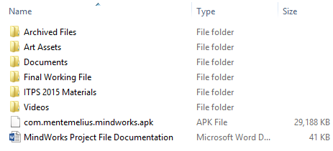

# APK File

APK is the file extension for Android Application Package, a package file format used to distribute and install application software and middleware onto any Android based platforms. Most Android platforms are mobile devices like phones and tablets which constitute the primary target platform for MindWorks.

This APK file is the latest build of MindWorks and can be deployed onto an Android device for a quick and easy installation of the game into said mobile device.

# Archived Files

Since the beginning of the project, a Mercurial based version control software was used to manage the project files and thus a large archive of older files exist within the version control. The primary keystones of the project and important changes have been extracted from the archive and added to this file.

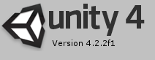

Each folder is a Unity project file which was developed using Unity version 4.2.2f. These archived files can be used to revert back to older iterations of the game or to view the development of the game.

When opening these files with older or newer versions of Unity, a Downgrade or Upgrade needs to be carried out by Unity on the file respectively. Upgrading or downgrading can sometimes cause irreparable damage to the files inside and thus a backup copy of the file should be created and stowed away before commencing any upgrade or downgrade operations.

The archived files’ names begin with the YYYY-MM-DD representation of the date the archive file was created. This aids in easy sorting and viewing the files in chronological order of their creation.

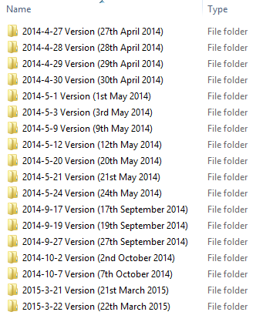

# Art Assets

The “Art Assets” folder is a huge collection of old art assets created for the project. Some of the oldest art assets date back to the pre-conceptualisation phase of the game. This archive of old art assets is organised into categories, each focusing on a particular type of asset. These categories tend to have their own sub categories for better organisation.

This archive can be used to see the progression of ideas from the “pen and paper” prototypes to digital representations of the game and finally to the completed final product.

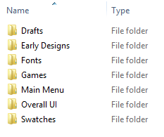

# Documents

The “Documents” folder is an archive of all the documented processes used in the development of the game. Schedules, check lists and testing feedback are amongst the documents present here.

This can be used to track to development of the game and how bugs were tackled in a systematic and efficient manner.

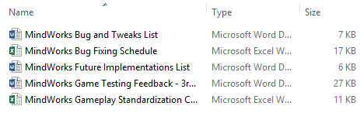

# Final Working File

This is probably the most important file present here. The “Final Working File” is the raw source codes and assets used in the final release of the game. This folder is a Unity project folder and, like the archived files, was developed using Unity version 4.2.2f.

The same upgrading and downgrading precautions should be applied to this file as well if using newer or older versions of Unity respectively.

This Unity project folder when opened can be used to redeploy the game to many other desired platforms including PC or Windows phones.

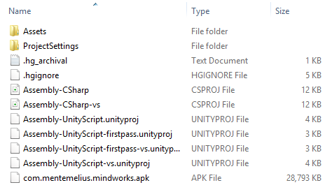

For the final working file, all 16 games that were developed for the project have been included. Although only 10 of the 16 game are presently active, the raw files and codes for the remaining games are present and fully operational.

Future improvements to the game could potentially activate some of these games and perhaps even improve on them.

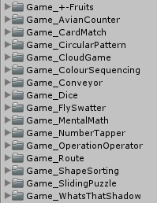

# ITPS 2015 Materials

This game was one of the two games from GET that was selected for the Information Technology Project Show 2015 (ITPS 2015). The materials prepared for the event are available in softcopy within this folder.

Amongst the items are, the game’s poster, PowerPoint slide presentation of the game as well the final write-up for the game.

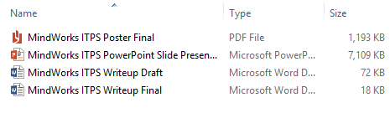

# Videos

This file contains all the video materials created for this project. It includes the MindWorks Trailer and two game walkthrough videos. A shortened ~10min version of the video and a full length ~15min version of the video. Both of the videos include a narrative about the game and how each segment is played.

The raw unedited working files used for the walkthrough videos are also included in this folder.

